**Computer Networks Lab#3**



**Session: 2021**

**Submitted by:**

**Wali Muhammad 2021-SE-39**

**Submitted to:**

**Sir Umer Rasheed**

Department of Computer Science

University of Engineering and Technology, Lahore, New Campus

1. Run nslookup to obtain the IP address of the web server for the Indian Institute of Technology in Bombay, India: www.iitb.ac.in. What is the IP address of www.iitb.ac.in

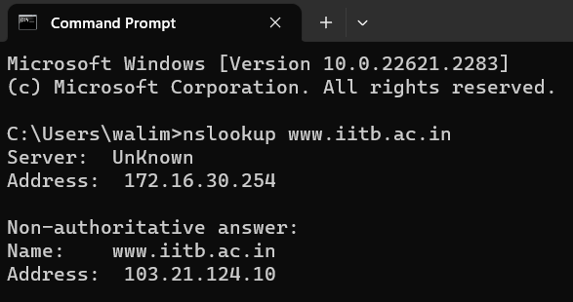

1. What is the IP address of the DNS server that provided the answer to your nslookup command in question 1 above?



1. Did the answer to your nslookup command in question 1 above come from an authoritative or non-authoritative server?

Non-authoritative server

1. Use the nslookup command to determine the name of the authoritative name server for the iit.ac.in domain. What is that name? (If there are more than one authoritative servers, what is the name of the first authoritative server returned by nslookup)? If you had to find the IP address of that authoritative name server, how would you do so?

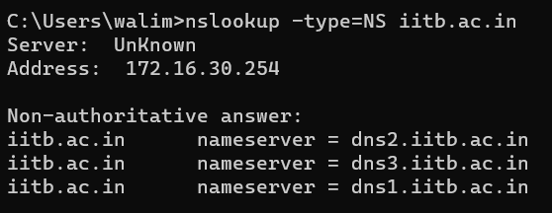

IP Address of the 1st server  
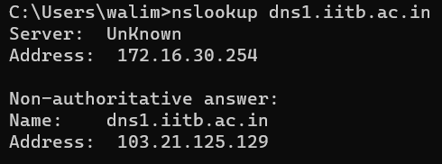

IP Address of 2nd server  
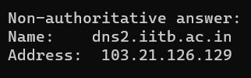

IP Address of 3rd server  
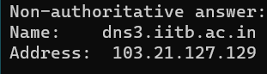

1. Locate the first DNS query message resolving the name gaia.cs.umass.edu. What is the packetnumber in the trace for the DNS query message? Is this query message sent over UDP or TCP?

Packet Number: 480

This query message is sent over UDP  




1. Now locate the corresponding DNS response to the initial DNS query. What is the packet number in the trace for the DNS response message? Is this response message received via UDP or TCP?

Packet Number: 492  
This response message received via UDP

  


1. What is the destination port for the DNS query message? What is the source port of the DNS response message?

Destination port for the DNS query message: 53  


Source port of the DNS response message is: 53



1. To what IP address is the DNS query message sent?   
     
   
2. Examine the DNS query message. How many “questions” does this DNS message contain? How many “answers” answers does it contain?



1. Examine the DNS response message to the initial query message. How many “questions” does this DNS message contain? How many “answers” answers does it contain?

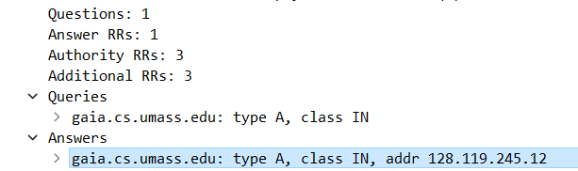

1. The web page for the base file http://gaia.cs.umass.edu/kurose_ross/ references the image object http://gaia.cs.umass.edu/kurose_ross/header_graphic_book_8E_2.jpg, which, like the base webpage, is on gaia.cs.umass.edu. What is the packet number in the trace for the initial HTTP GET request for the base file http://gaia.cs.umass.edu/kurose_ross/? What is the packet number in the trace of the DNS query made to resolve gaia.cs.umass.edu so that this initial HTTP request can be sent to the gaia.cs.umass.edu IP address? What is the packet number in the trace of the received DNS response? What is the packet number in the trace for the HTTP GET request for the image object http://gaia.cs.umass.edu/kurose_ross/header_graphic_book_8E2.jpg? What is the packet number in the DNS query made to resolve gaia.cs.umass.edu so that this second HTTP request can be sent to the gaia.cs.umass.edu IP address? Discuss how DNS caching affects the answer to this last question.

Packet number of the initial HTTP GET request is 576.  
Packet number = Frame number



Packet number of the DNS query made to resolve gaia.cs.umass.edu  


Packet number of the received DNS response  
  
  
 Packet number for the HTTP GET request for the image object is 685.  
 

1. What is the destination port for the DNS query message? What is the source port of the DNS response message?  
     
   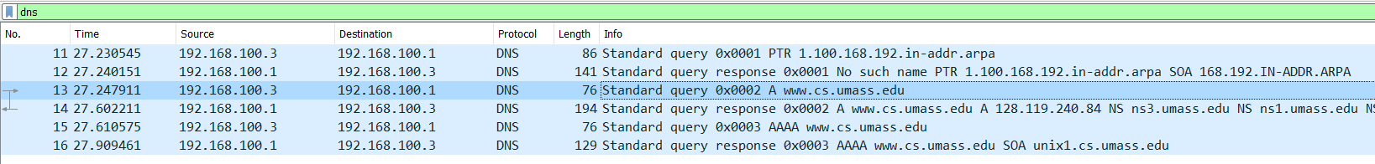

Destination Port for the DNS query message:   
  
Source port of the DNS response message:  


1. To what IP address is the DNS query message sent? Is this the IP address of your default local DNS server?

The DNS query message is sent to the IP address 192.168.100.1, and this is not the IP address of my default local DNS server. I am capturing these packets on my laptop, which has the IP address 192.168.100.3.



1. Examine the DNS query message. What “Type” of DNS query is it? Does the query message contain any “answers”?  
     
   The query is standard query of type A and it doesn’t contain any answers.  
     
   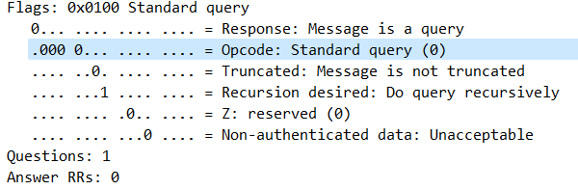
2. Examine the DNS response message to the query message. How many “questions” does this DNS response message contain? How many “answers”?

The response DNS message contains one answer containing the name of the host, the type of address, the class, and the IP address.

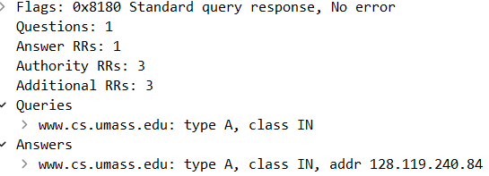

1. To what IP address is the DNS query message sent? Is this the IP address of your default local DNS server?

The DNS query message is sent to the IP address 192.168.100.1, and this is not the IP address of my default local DNS server. I am capturing these packets on my laptop, which has the IP address 192.168.100.3.



1. Examine the DNS query message. How many questions does the query have? Does the query message contain any “answers”?

It’s a type NS DNS query that doesn’t contain any answers.

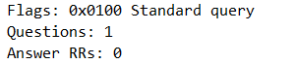

1. Examine the DNS response message. How many answers does the response have? What information is contained in the answers? How many additional

: One answer is provided in the DNS response message. It contains the following:

